1. **Create s3 bucket and upload some objects to s3.**

--- A techidev07 S3 bucket has been created

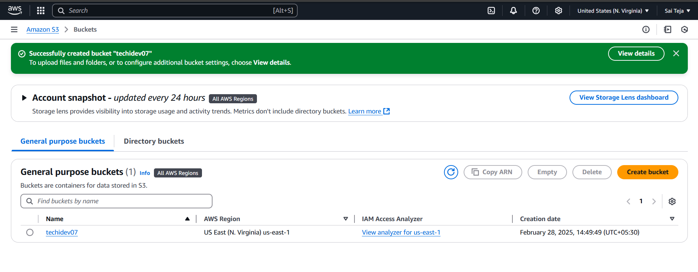

A objects ha been added into the techidev07 bucket

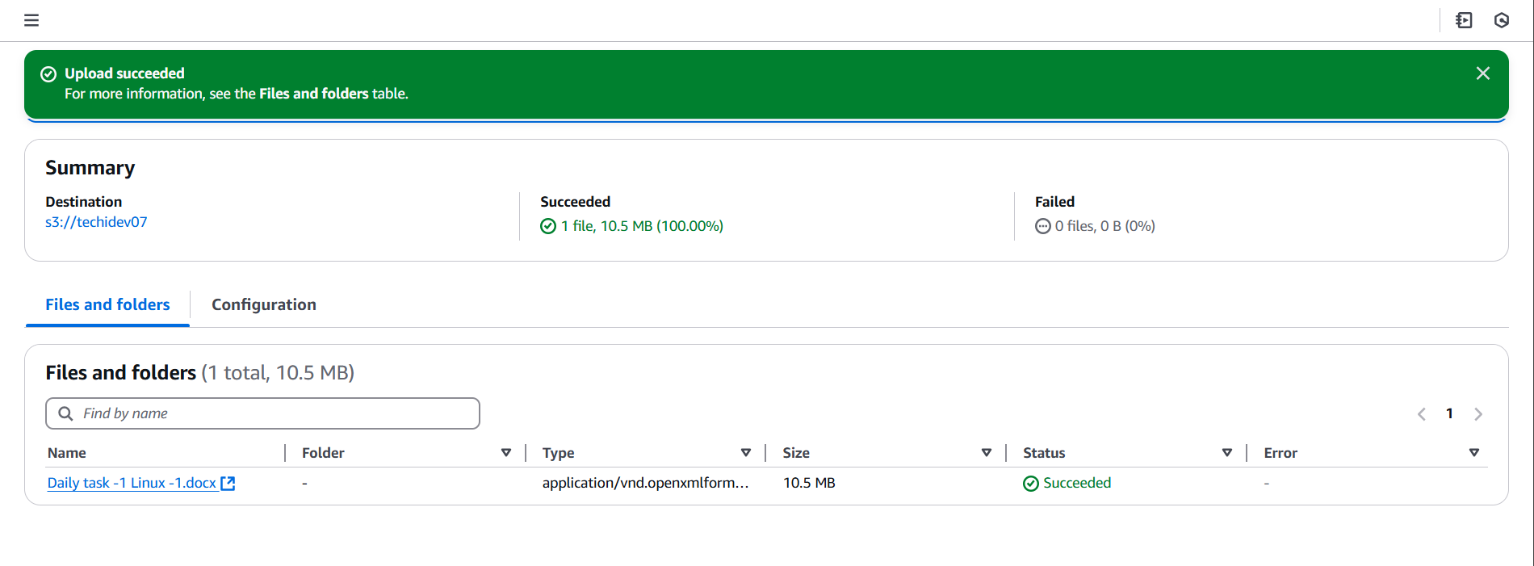

1. Deploy static website in s3 bucket.

---- Add 2 file to the bucket i.e index.html and error.html

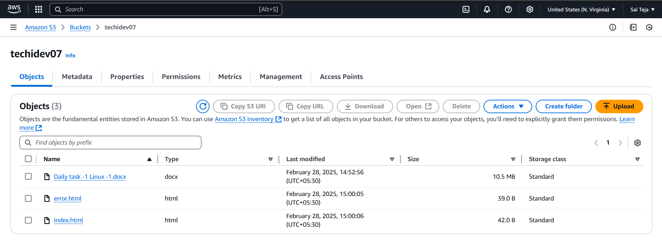

--- go to properties and add 2 files in the Static website hosting then save

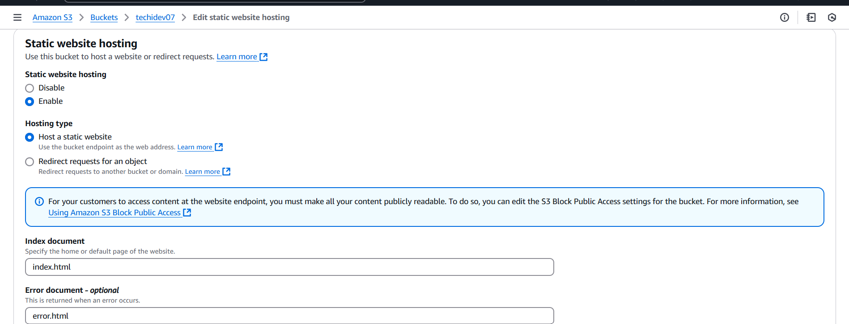

---- copy and paste the url of bucket in browser

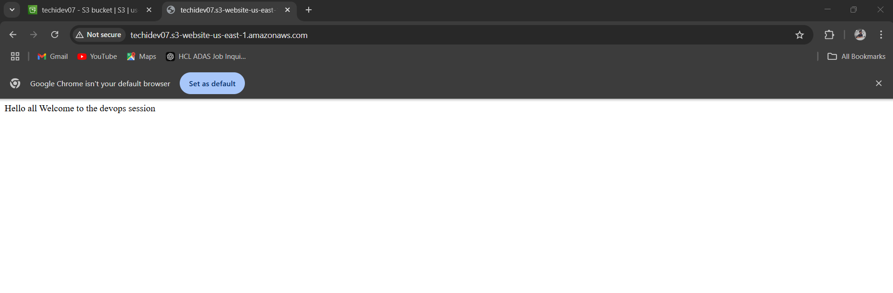

1. Enable cross region replication on s3 buckets

-------go to management Create one replication in the source bucket

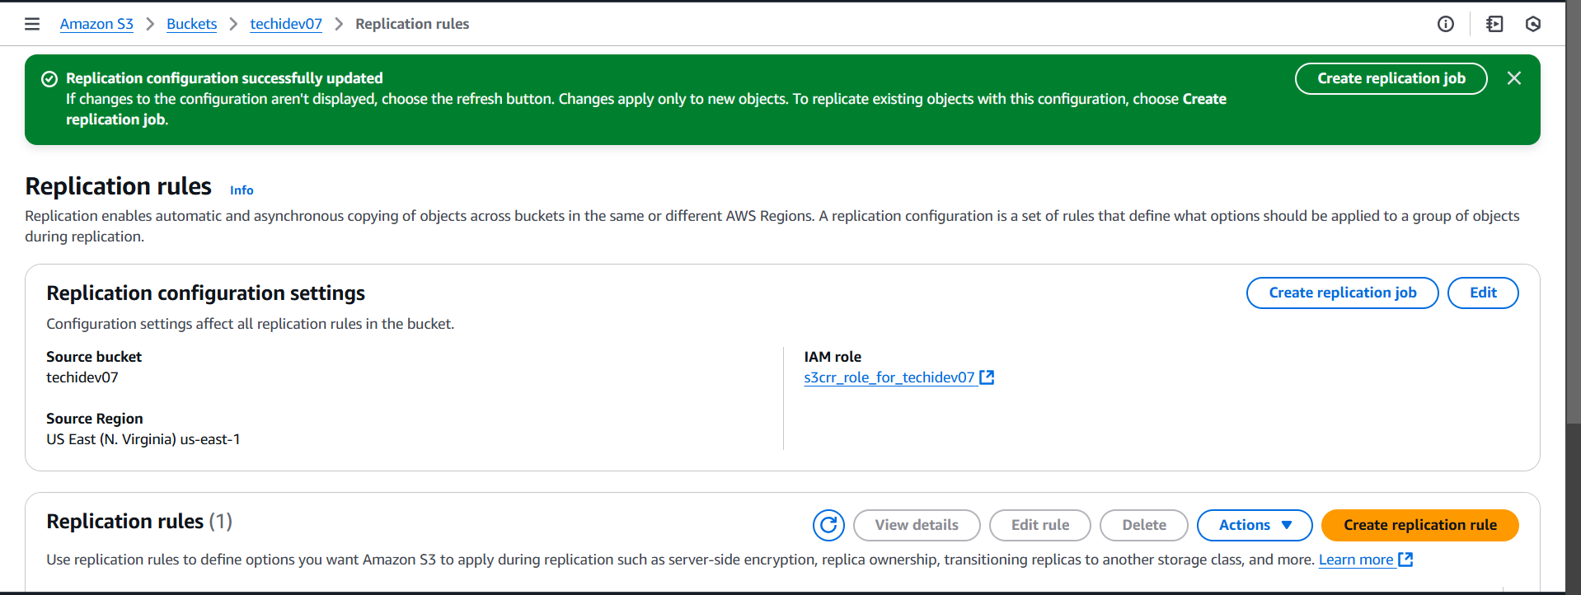

Created 2 bucket in 2 different regions

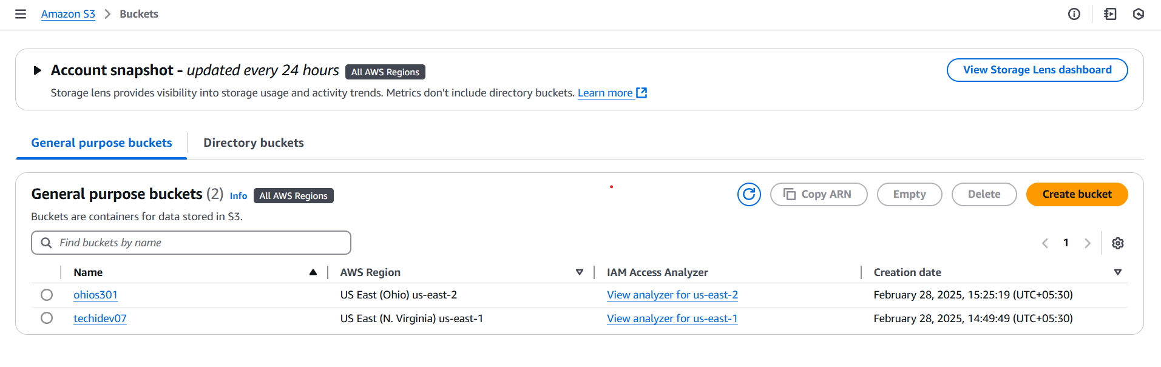

Check for the destination bucket we can see no objects are found

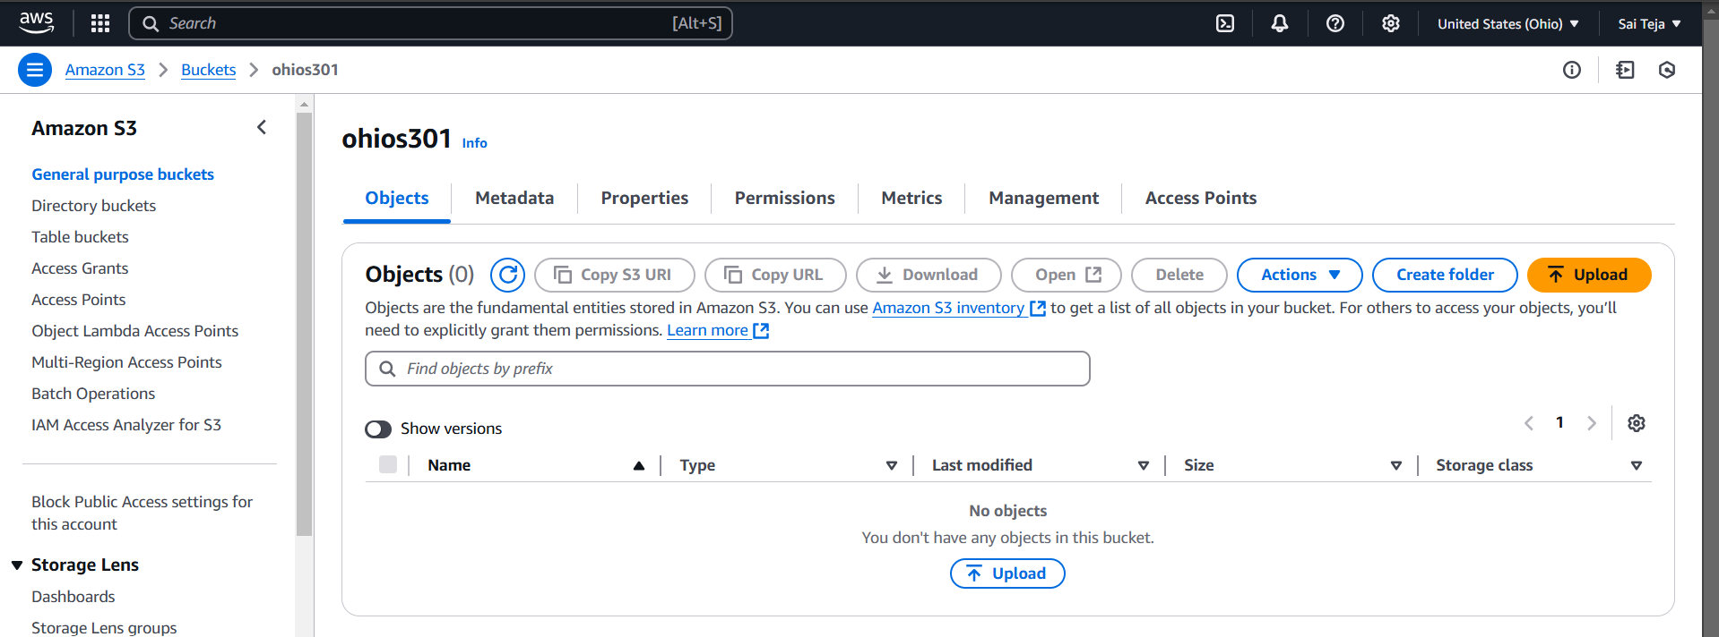

Uploaded one object in source bucket [ challenge]

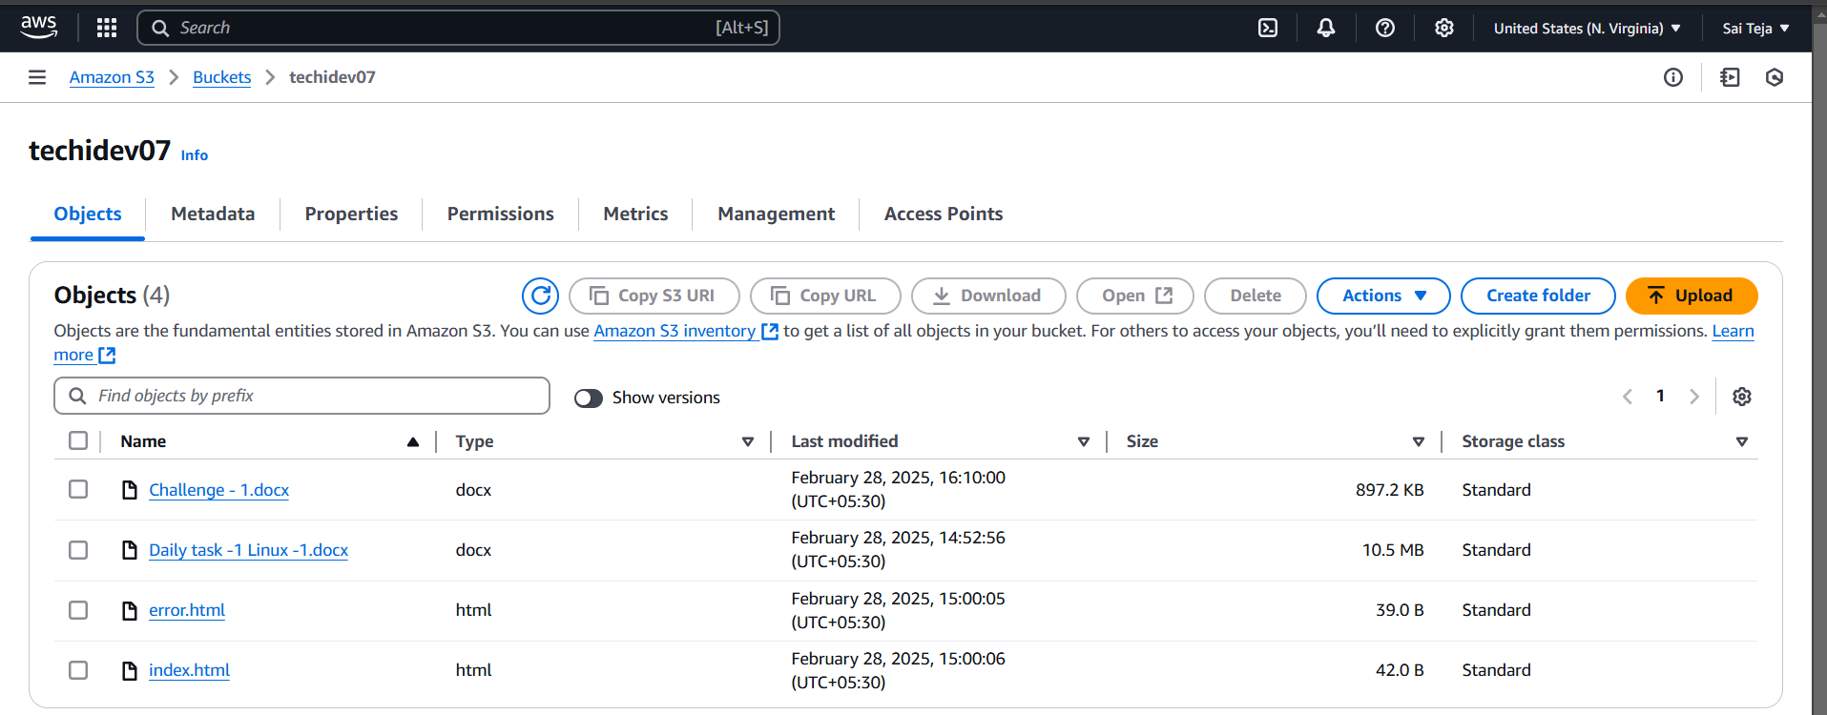

Go to the destination bucket we can find the object uploaded in the source bucket

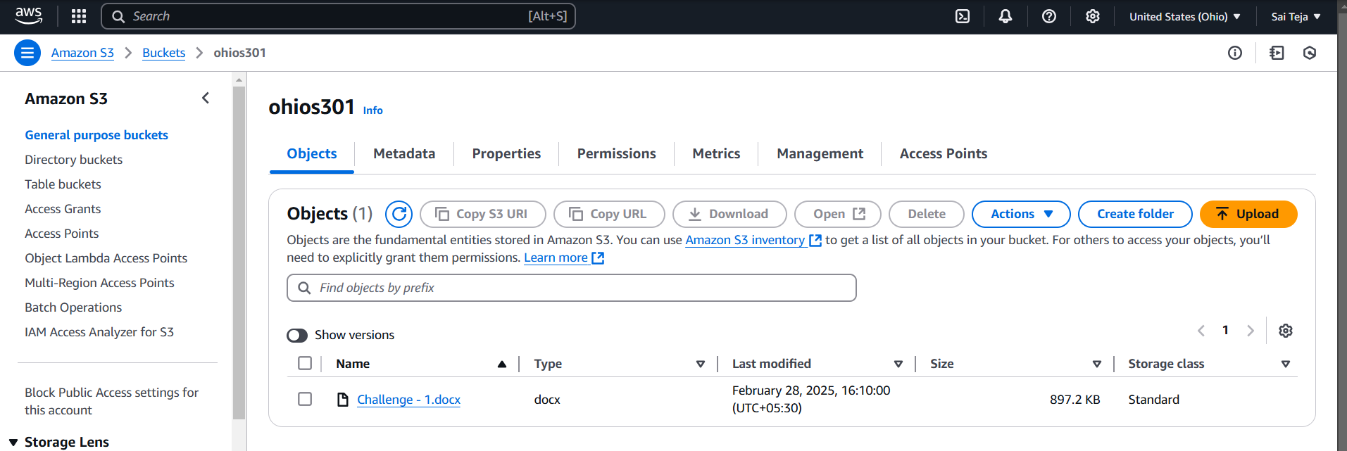

1. Configure bucket policy,only Admin user can see the objects of s3 bucket

--- add policy to the techidev07 bucket using below script

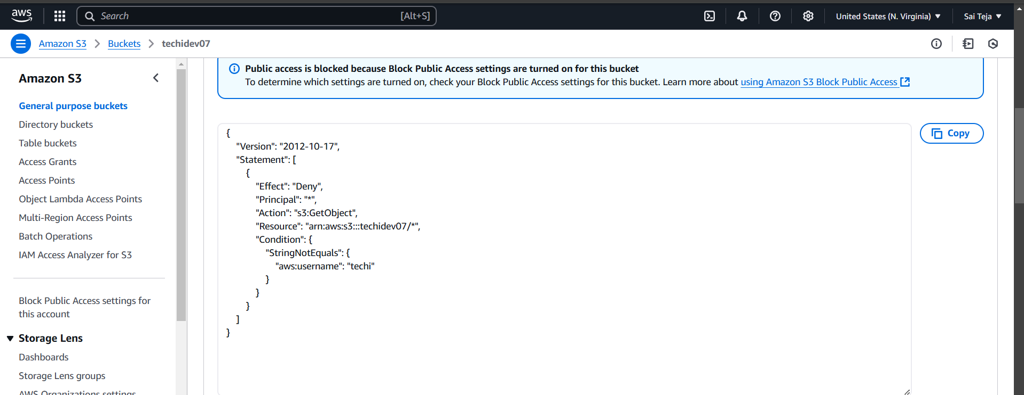

Create an IAM user and provide below policy to the IAM user (techi)

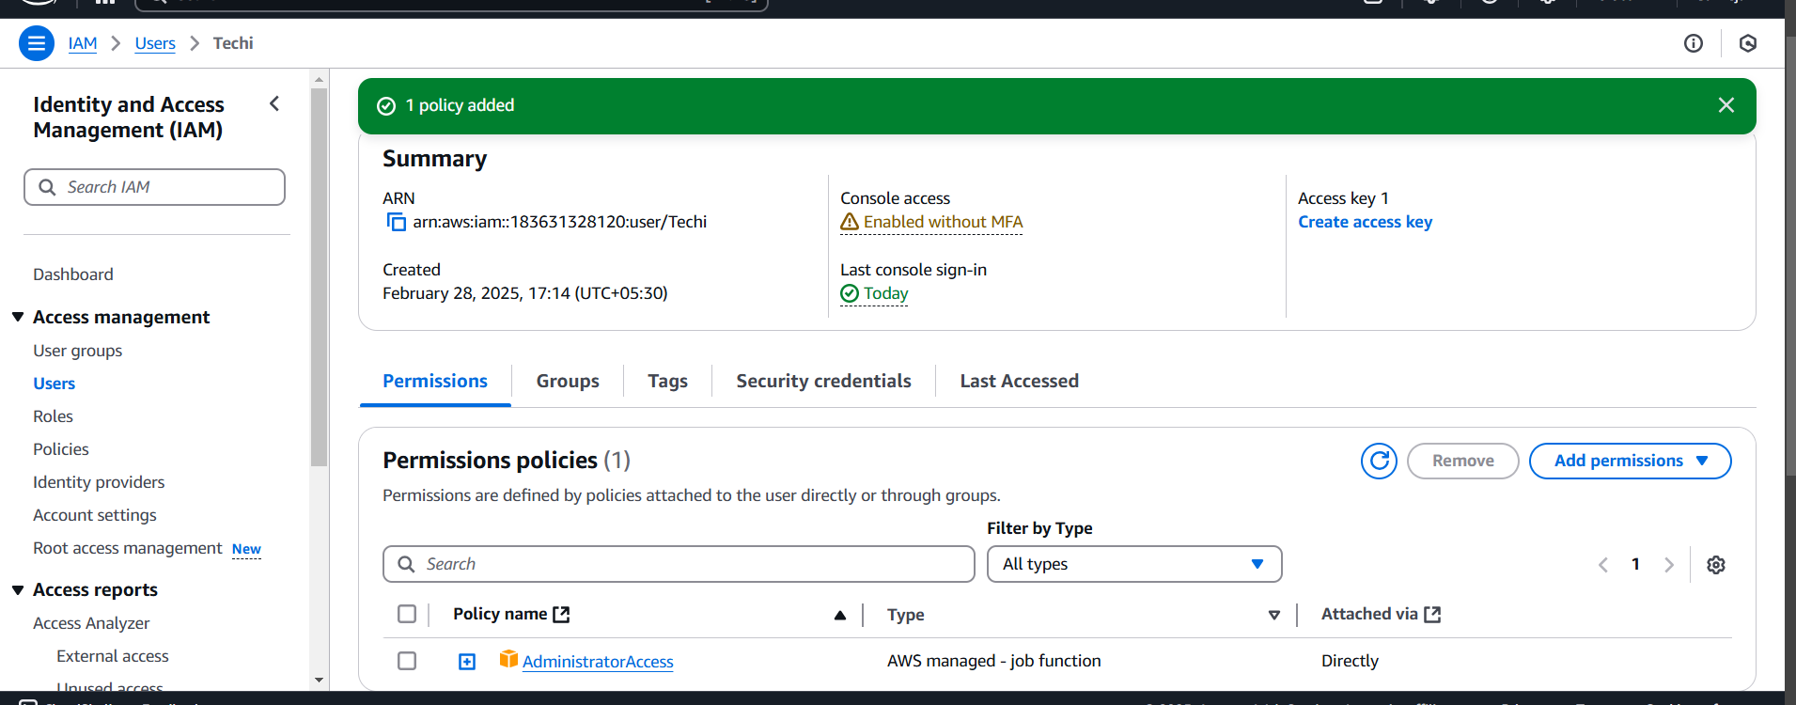

Login into IAM user search for S3 we can all the buckets

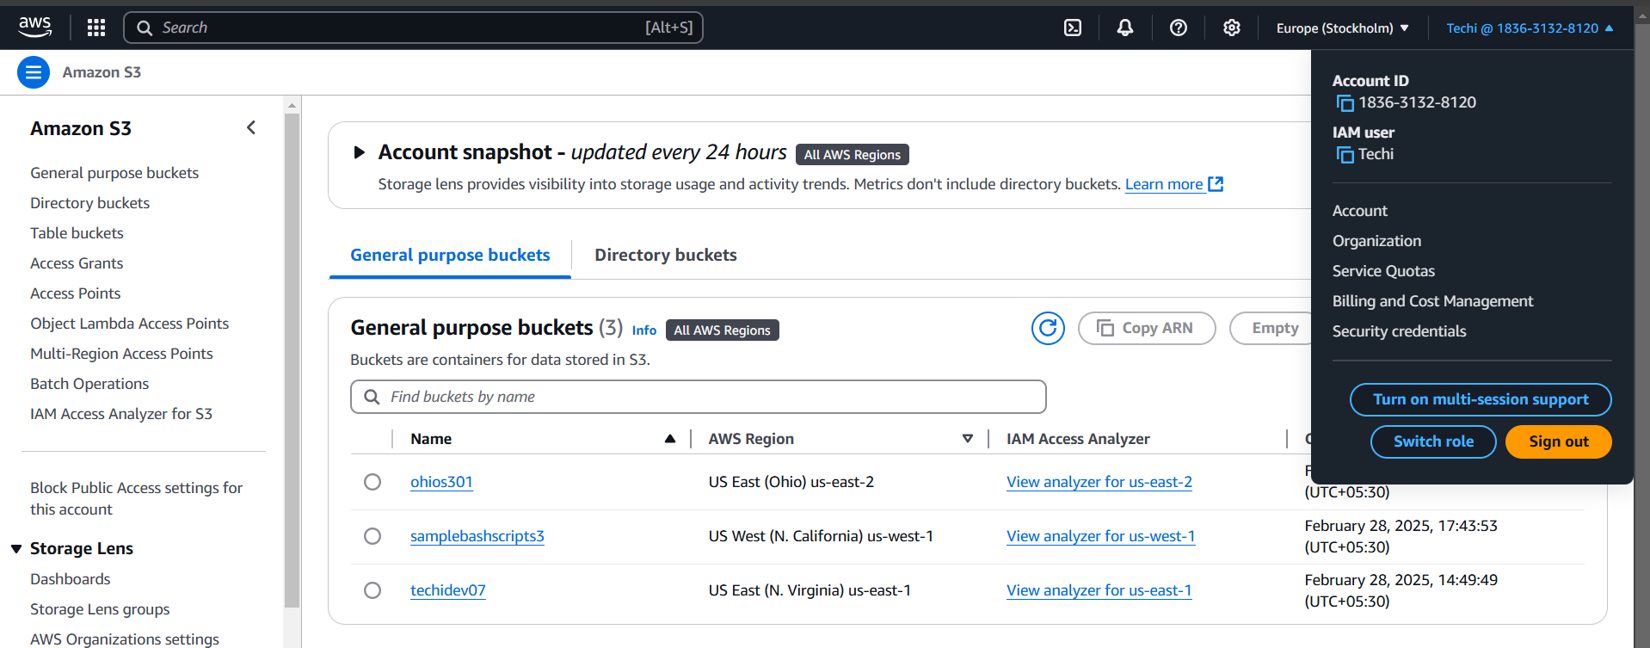

--remove policy to IAM user (techi) we can see no buckets

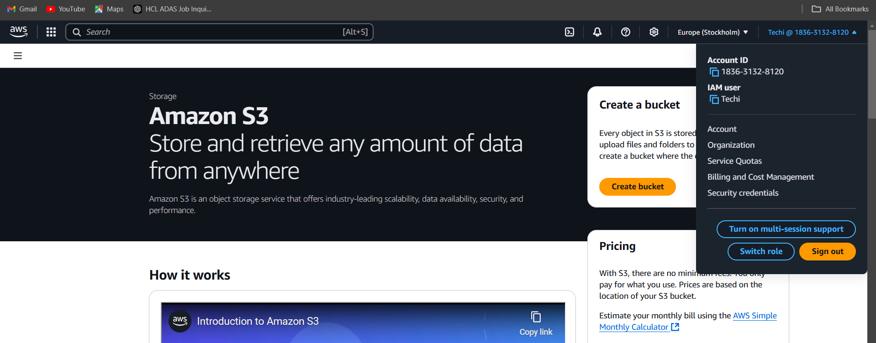

1. Setup lifecycle policies to automatically transition or delete objects based on specific criteria.

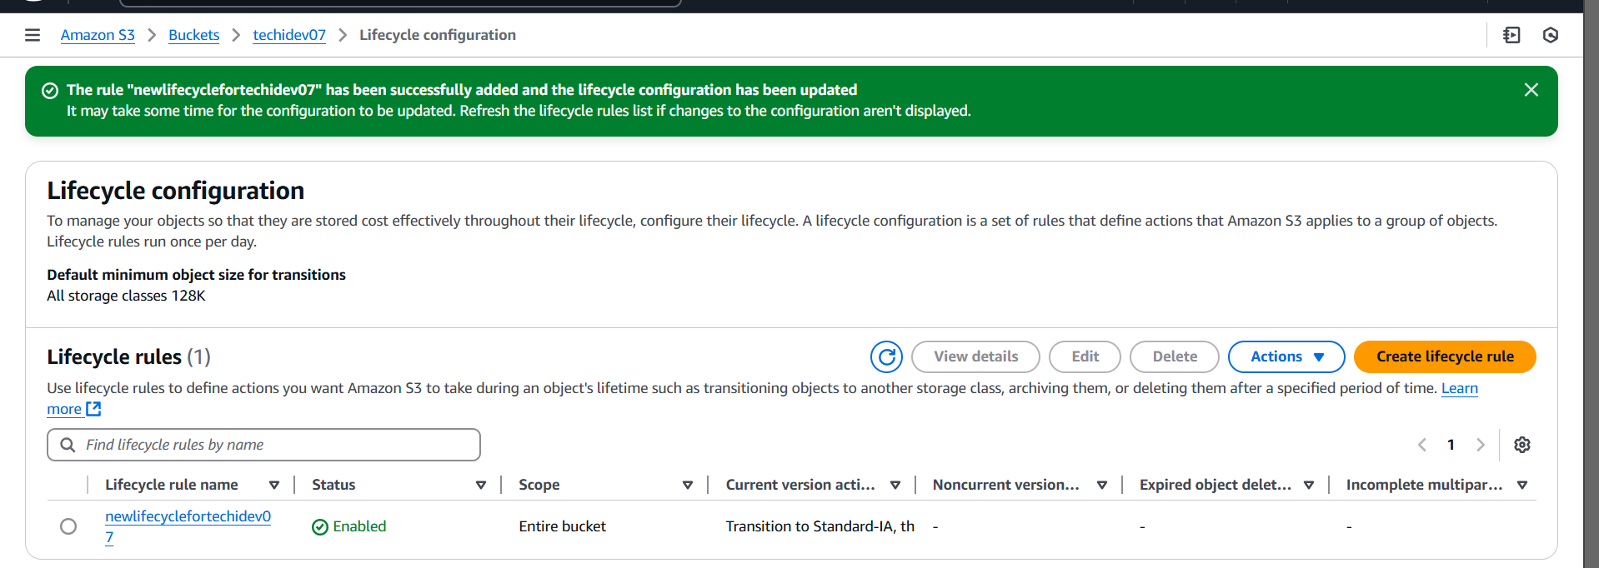

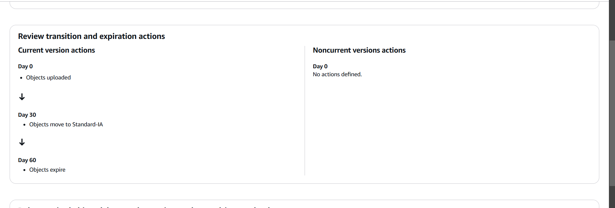

1. Push some objects in s3 using AWS CLI.

--- having sample_s3 file



----using aws s3 ls command we can list no .of s3buckets

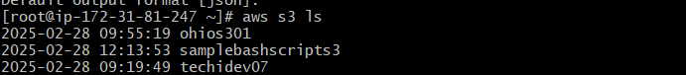

----using aws s3 cp filename s3://nameofs3bucket/



---- successfully file uploaded into ohios301 bucket

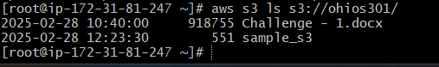

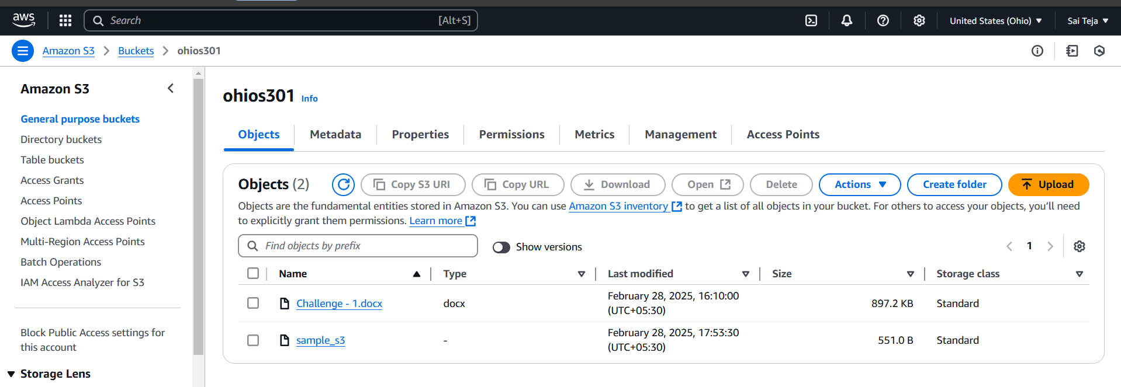

7) Write a bash script to create s3 bucket.

----created a samplebashscripts3 bucket using the below bash script

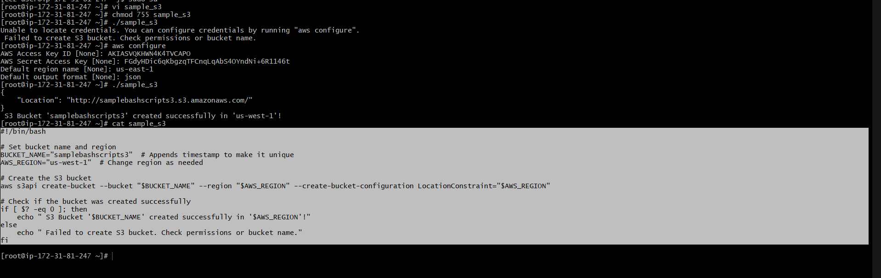

We can see samplebashscripts3 has been successfully created

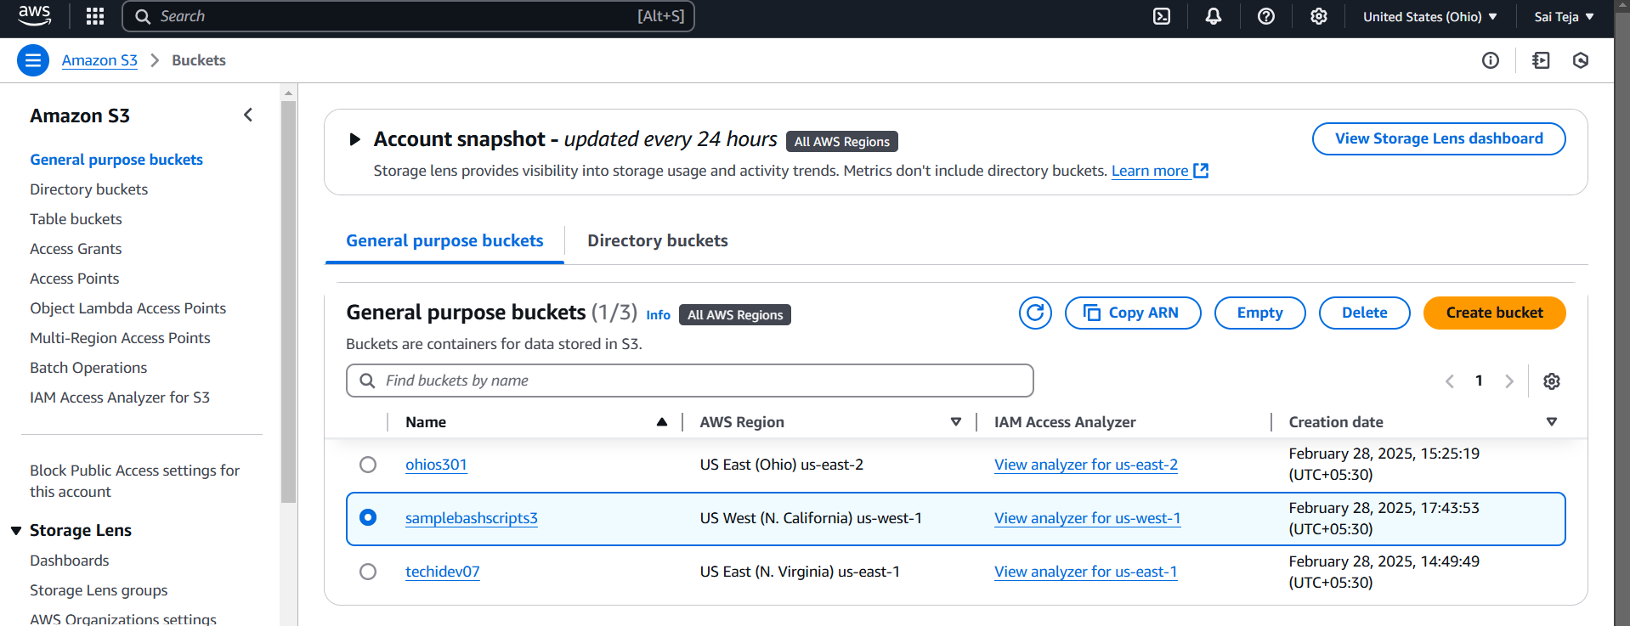

1. Upload one 1 gb of file to s3 using cli.

